Homework 1 Student Name: Malayanur Narahari Rahul

AuE 8930: Machine Perception and Intelligence

Instructor: Dr. Bing Li, Clemson University, Department of Automotive Engineering

* Refer to [Syllabus](https://tinyurl.com/syllabus-perception) for homework grading, submission and plagiarism policies;

* Submission to Canvas (Due: Tues. Jan. 19, 2021 11:59 pm), including:

* This document (with answers), and with your program results/visualization;

For this homework, you may put the screenshots of the results in the submission document.

* A .zip file of source code (and data if any) with names indicating question number;

* You can find some sample codes from the course [GitHub Repo](https://github.com/fengziyue/AUE-8939-Perception-Intelligence);

1. Download [NuScene](https://www.nuscenes.org/download) dataset, you may need to register on that website. To save time, you can only download the [mini](https://www.nuscenes.org/data/v1.0-mini.tgz) set with its [Lidarseg](https://www.nuscenes.org/data/nuScenes-lidarseg-mini-v1.0.tar.bz2) file. (5 points)

Downloaded the dataset along with the lidarseg file.

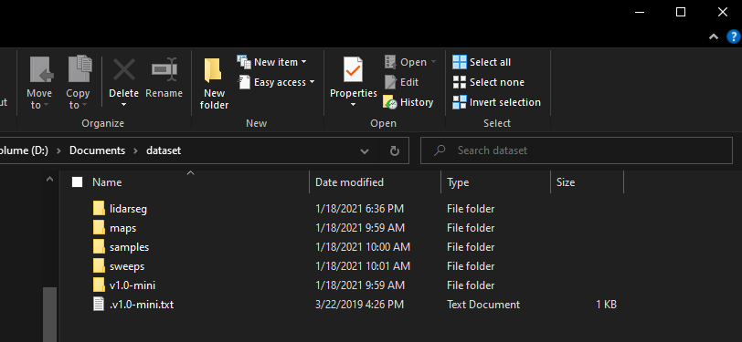

1. Set up the NuScene [develop kit](https://github.com/nutonomy/nuscenes-devkit) locally, you may need to install Anaconda and Jupyter notebook. (5 points)

Sol: Installed Anaconda and Jupyter locally. Setup of develop kit of NuScene was successful.

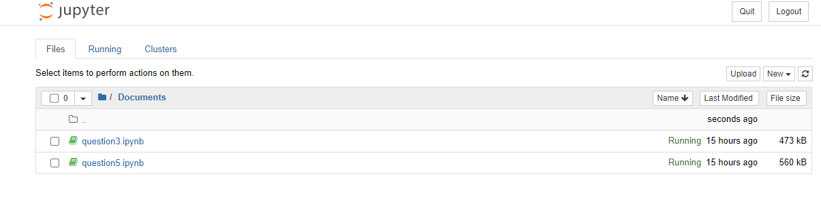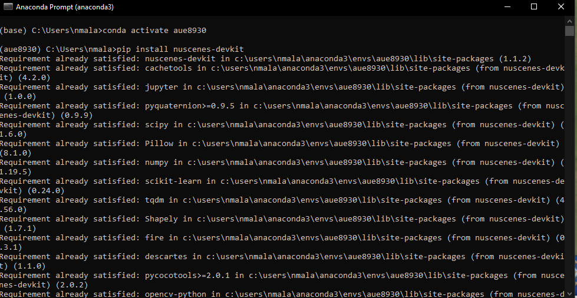

1. Pickup a set of data, including Image, Lidar, and Radar data. Visualize them with NuScene dev-kit tutorial notebooks, [reference code (which is Jupyter notebook Python)](https://github.com/nutonomy/nuscenes-devkit/tree/master/python-sdk/tutorials). (20 points)

Sol: Camera Image

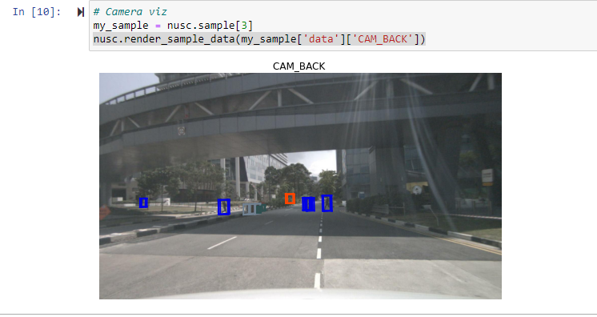

Lidar

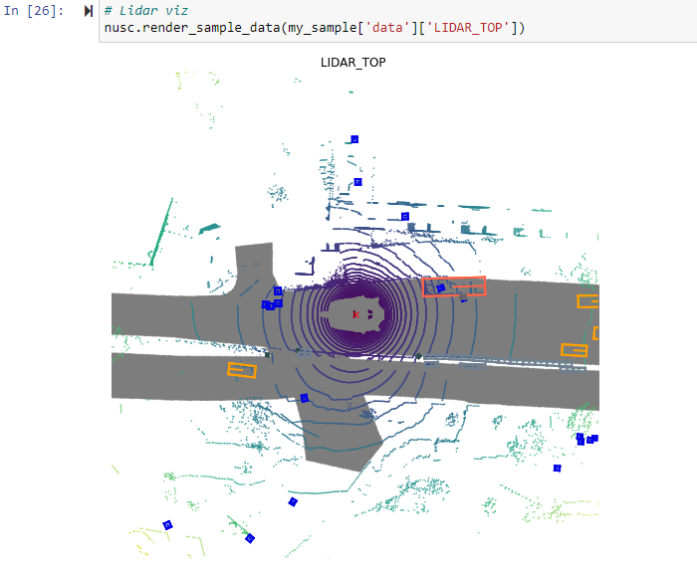

Radar

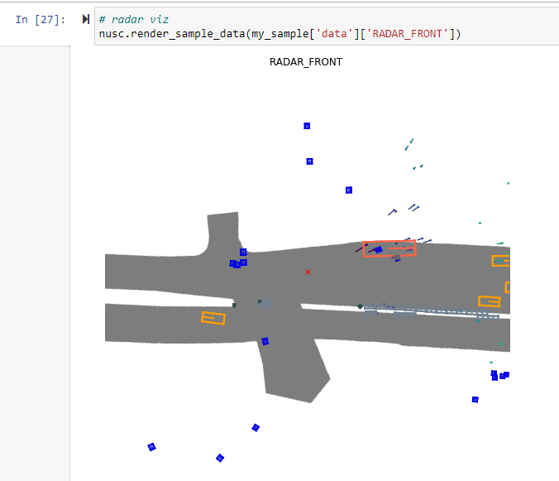

1. Rather than using the dev-kit, implement (total 55 points):
2. Visualize images (using OpenCV or others you prefer), [Sample code](https://github.com/fengziyue/AUE-8939-Perception-Intelligence/blob/main/Homework1/Visualize-Image.py). (5 points)

Sol:

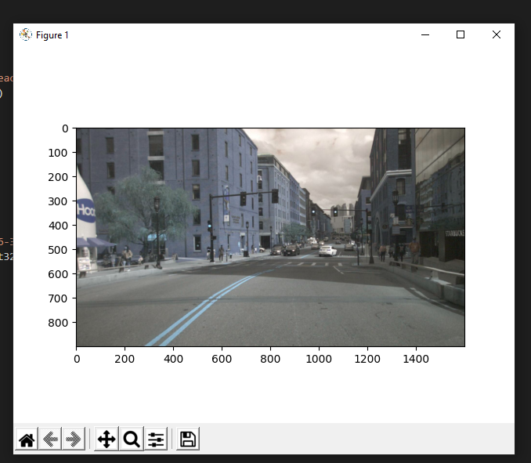

1. Visualize Lidar point cloud data
   1. You can refer to this [sample code](https://github.com/fengziyue/AUE-8939-Perception-Intelligence/blob/main/Homework1/Visualize-Lidar.py).

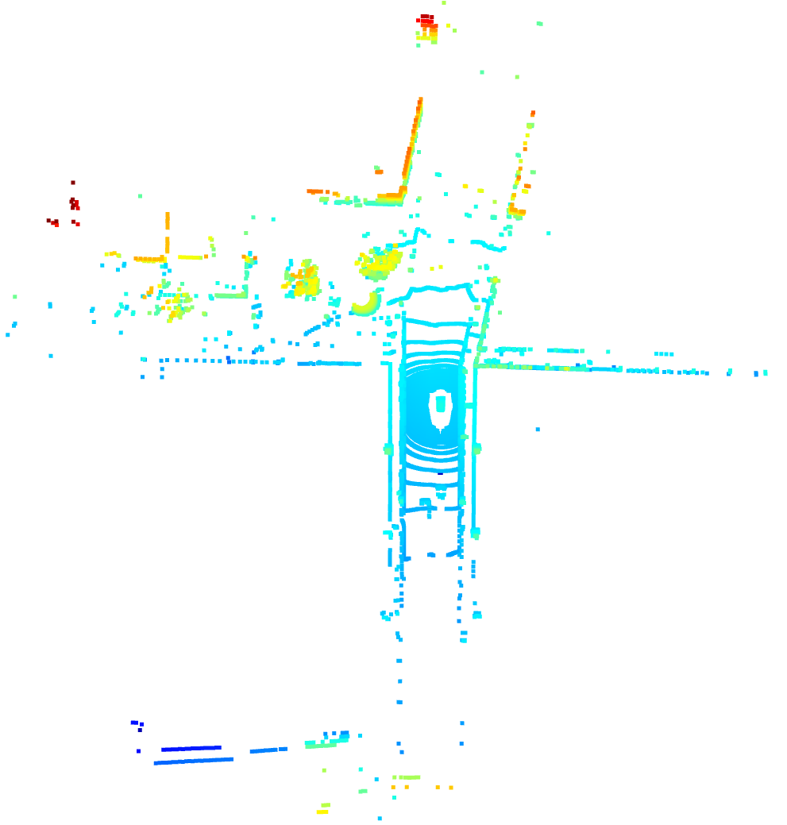

* 1. Colorize points by height, intensity, and semantic label respectively. (20 points)
     1. Height is the Z value for a point.

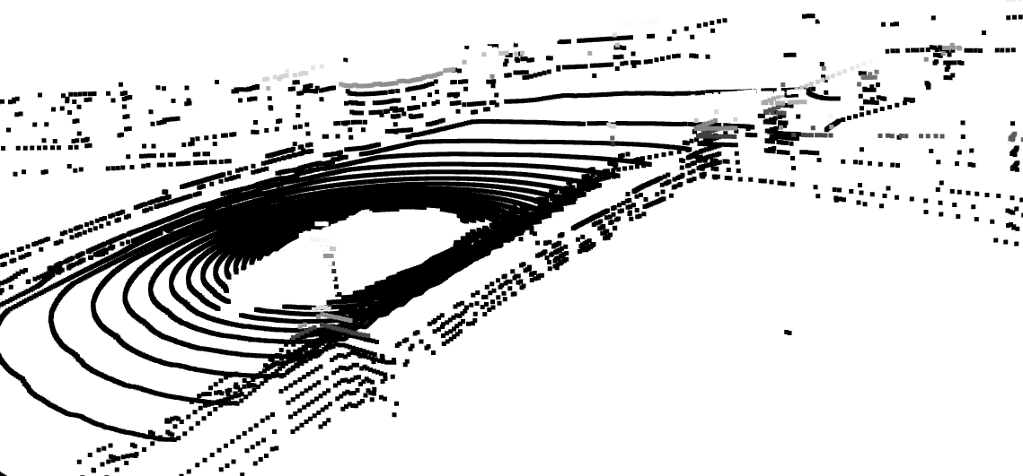

* + 1. You can get intensity from [here](https://github.com/nutonomy/nuscenes-devkit/blob/5325d1b400950f777cd701bdd5e30a9d57d2eaa8/python-sdk/nuscenes/utils/data_classes.py#L234).

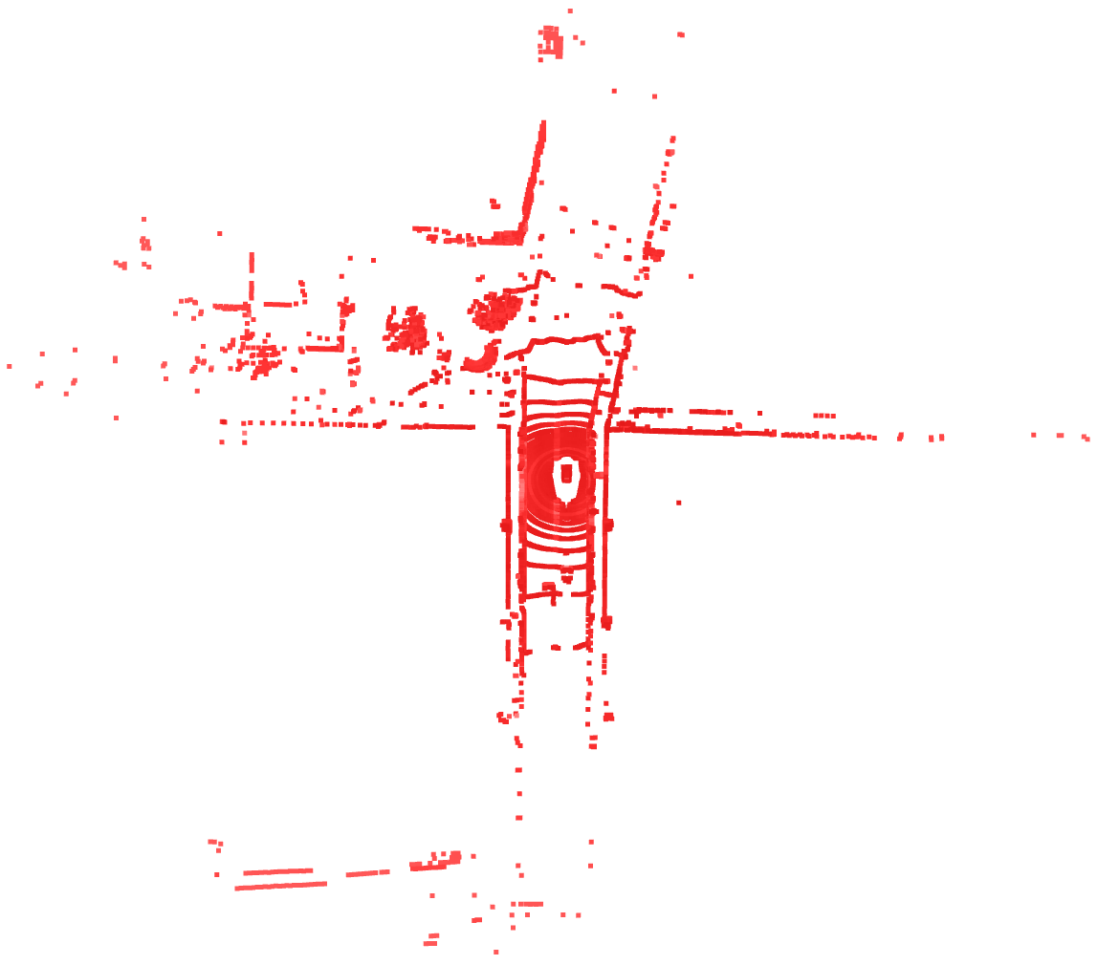

* + 1. You can get semantic label from the sample code.

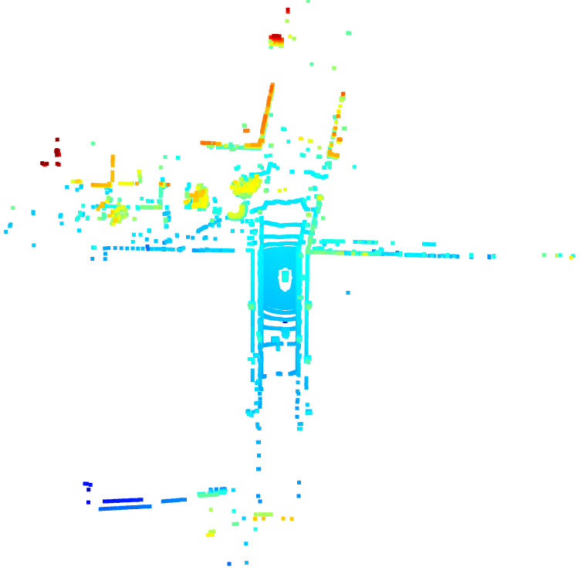

1. Visualize Radar data
2. Use another library or modify the previous sample code to make it works for the visualization of the Radar data which you picked up. (10 points)

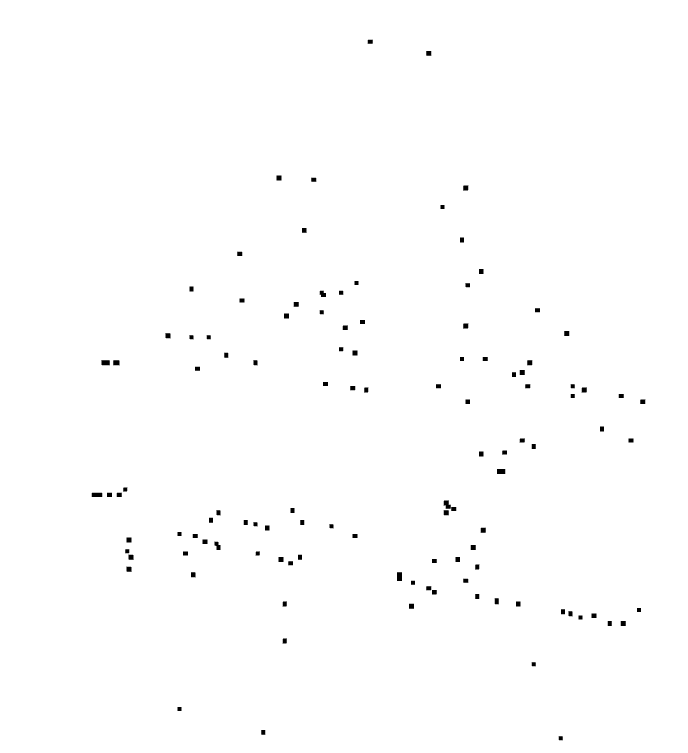

1. Colorize points by height and velocity respectively. (20 points)
   * 1. You can find some velocity information from [here](https://github.com/nutonomy/nuscenes-devkit/blob/5325d1b400950f777cd701bdd5e30a9d57d2eaa8/python-sdk/nuscenes/utils/data_classes.py#L259:1).

Height:

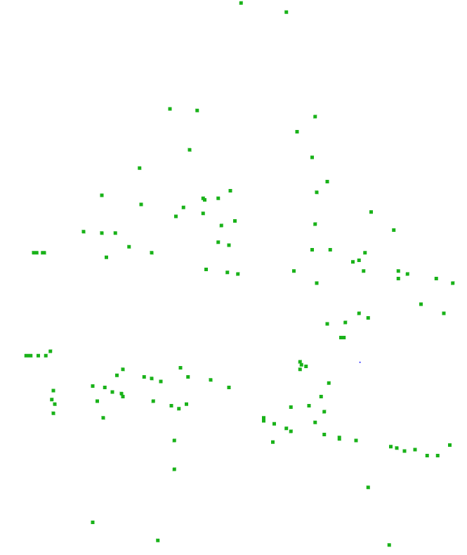

Velocity:

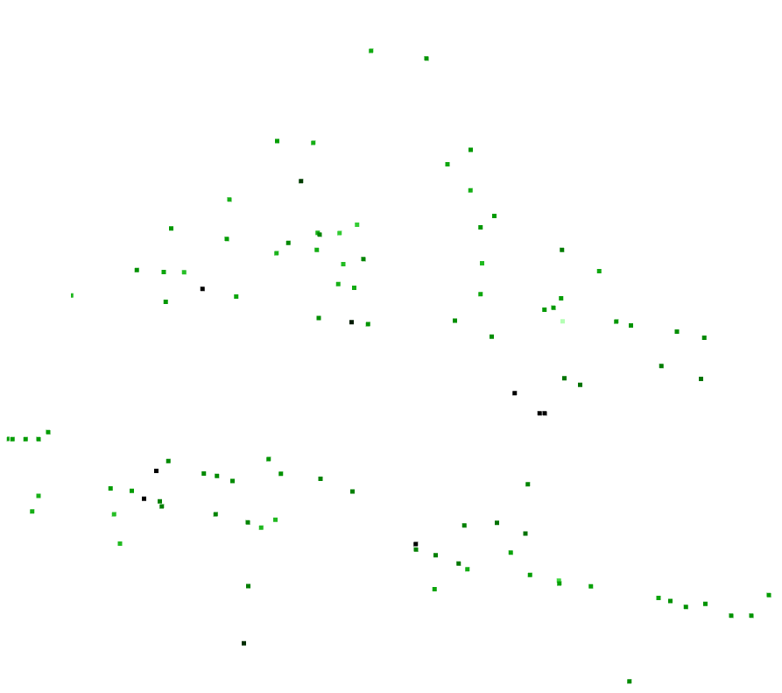

1. Using NuScene dev-kit for the set of data which you picked up: (15 points)
2. Visualize Radar data projection on image (10 points).

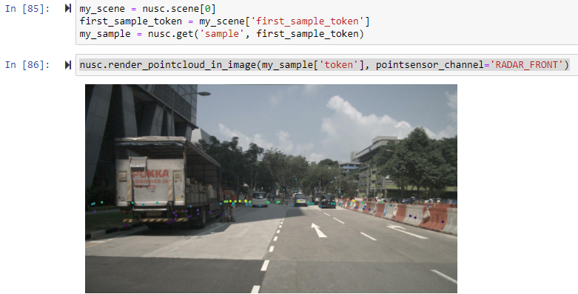

* 1. Print calibration info (between Radar and Camera sensors) by referring [here](https://github.com/nutonomy/nuscenes-devkit/blob/5325d1b400950f777cd701bdd5e30a9d57d2eaa8/python-sdk/nuscenes/nuscenes.py#L740).

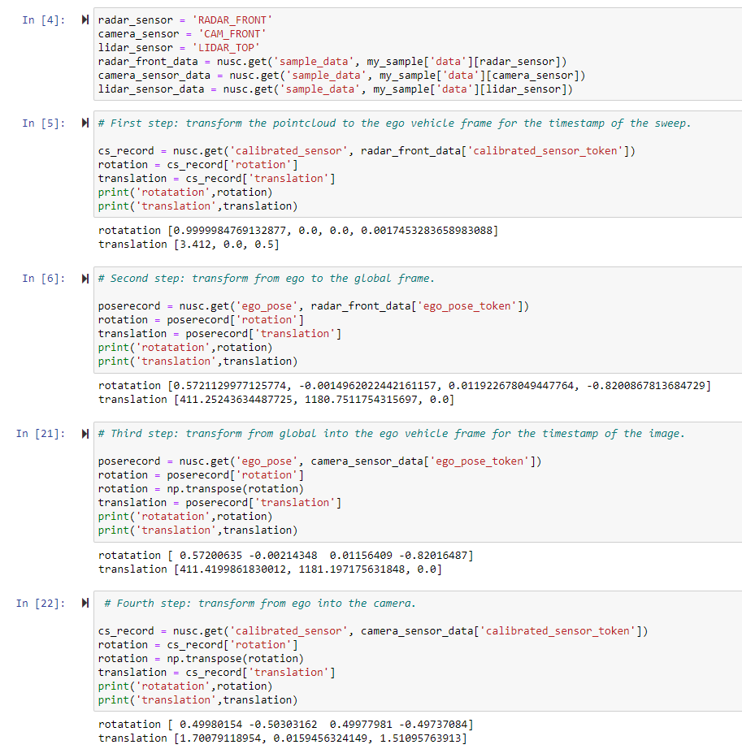

* 1. Explain the above calibration info, and the pipeline of First step ~ Fifth step.

Sol:

The goal here is to visualize the radar data projected on a image. To achieve, these following steps are required.

First step: The radar point cloud will transform to the ego vehicle frame.

Second step: Then the transform is from the ego frame to the global frame.

Third step: The camera image is then transformed from global frame to the ego frame.

Fourth step: Then the transform is from the ego vehicle into the camera.

1. Visualize LiDAR data projection on image (5 points).

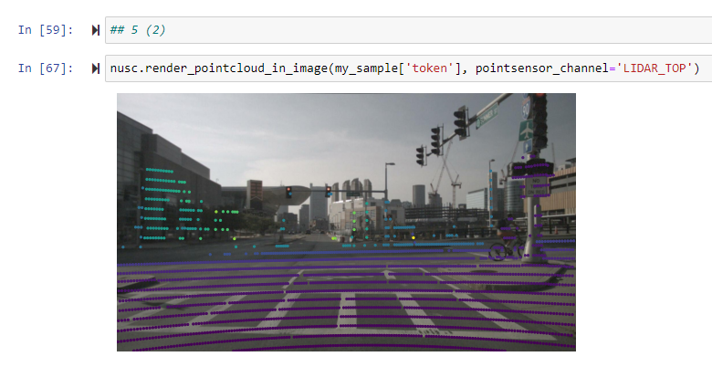

* 1. Print calibration info (between LiDAR and Camera sensors) by referring [here](https://github.com/nutonomy/nuscenes-devkit/blob/5325d1b400950f777cd701bdd5e30a9d57d2eaa8/python-sdk/nuscenes/nuscenes.py#L740).

